**Hardware Requirements Specification**

**for “*LaneSense: Autonomous Lane Detection RC Car*”**

**Version 1.0**

**Date: October 1, 2023**

**Name:**

**Dominic Lau**

**For Course/Teacher:**

**Mr.Roller (TEJ4M)**

**Table of Contents**

**1. Executive Summary** 2

1.1 Project Overview 3

1.2 Purpose and Scope of this Specification 3

**2. Product Description 3**

2.1 Product Context 4

2.2 User Characteristics 4

2.3 Assumptions/Risks 4

2.4 Constraints 5

2.5 Dependencies 5

**3. Requirements (Bulk of this Document!) 6**

3.1 Functional and Hardware Requirements 6

3.2 User Interface Requirements 6

**3.3 Hardware Interfaces 7**

3.3.1 Internal Interfaces 7

3.3.2 External Interfaces 8

**4. Requirements Confirmation/Stakeholder sign-off**

Appendix **8**

# Executive Summary

## ***Project Overview***

This project targets students (high school and college levels) and hobbyists interested in learning about robotics and computer vision. The Lane Detection RC Car is an educational and recreational project featuring a remote-controlled car with a camera for autonomous lane detection. Users can switch between autonomous and manual modes for learning and fun.

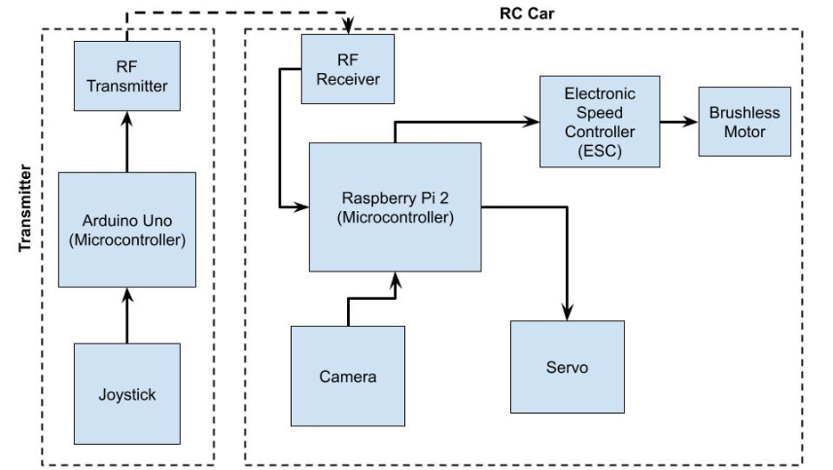

## ***Purpose and Scope of this Specification***

This project aims to design and build an RC (Remote Control) car equipped with lane detection technology. The purpose of this specification is to outline the key objectives, requirements, and scope of the project. As the designer, you will work under the supervision of your teacher, who plays the role of the project manager. The client for this project is a hypothetical entity interested in creating an educational RC car. The end users are students and hobbyists who want to learn about computer vision and robotics.

**Scope of Use:**

The Lane Detection RC Car is intended for educational purposes, primarily in STEM (Science, Technology, Engineering, and Mathematics) programs and hobbyist communities. It will serve as a learning tool to teach concepts related to computer vision, machine learning, and robotics. The car will be capable of detecting lanes on the ground and autonomously following them while also allowing manual control. The project must meet all relevant curriculum expectations as well as requirements as suggested by the client.

**Project Duration:**

The project is estimated to span one academic semester. Specific project milestones and deadlines will be established later in the project planning phase, but a rough timeframe would be approximately 4-5 months to complete the design, development, testing, and documentation phases.

# Product Description

## ***Product Context***

LaneSense is developed on the foundation of existing 3D printed RC car designs. It utilizes the chassis and structural components commonly associated with these vehicles.

LaneSense distinguishes itself by incorporating autonomous technology, such as sensors and software, to enable lane detection and autonomous operation. This integration sets it apart from traditional manually operated RC cars.

## ***User Characteristics***

**Middle School to University** **Students** - Basic to moderate familiarity with remote control car operation

**Teachers** – Varied technical backgrounds, with a good understanding of technology.

## ***Assumptions/Risks***

2.3.1. **Availability of Required Hardware**: It is assumed that the necessary hardware components such as cameras, motors, microcontrollers (e.g., Raspberry Pi), and remote controllers will be readily available in the market for the construction of the LaneSense RC Car. Any supply chain disruptions could impact the project timeline.

2.3.2. **Operating System Compatibility** The software and programming environment assumes the availability and compatibility of specific operating systems (e.g., Raspbian for Raspberry Pi). If these operating systems become obsolete or incompatible, adjustments to the software may be needed.

2.3.3. **Interference and Noise:** It is assumed that the radio communication will operate in an environment with minimal interference and noise. Extensive interference or noise levels may necessitate the use of error correction techniques or alternative communication protocols.

2.3.4. **Software Dependencies**: The project relies on specific software libraries and dependencies for computer vision and control. It is assumed that these libraries will remain available and supported. Changes or discontinuation of these dependencies may necessitate software adjustments.

2.3.5. **Camera Quality**: The effectiveness of lane detection relies on the quality and performance of the onboard camera. It is assumed that the camera meets the specified requirements for resolution and frame rate.

## ***Constraints***

2.4.1 **System Resource Constraints:** The onboard hardware (e.g., Raspberry Pi) may have limitations such as limited processing power, memory, or disk space. The design must optimize resource usage to ensure smooth operation and responsiveness.

2.4.2 **Budget Constraints:** Budget limitations may affect the selection of components and materials for the RC car. The design must align with the available financial resources.

## ***Dependencies***

2.5.1 **Design and Modelling:** The completion of the 3D model designs for the RC car chassis, components, and housing is a prerequisite for production. The production process relies on finalized design specifications.

2.5.2 **Acquiring Hardware**: The project's progress relies on the timely availability of various hardware components, including 3D printing equipment, sensors, microcontrollers, and power supplies. The completion of hardware integration and testing is contingent upon the procurement and readiness of these essential components.

2.5.3 **Completion and Assembly of the RC Car:** The development of software modules for lane detection, remote control, and sensor integration is contingent upon the successful completion and assembly of the RC car hardware. Software development and integration cannot proceed until the hardware system is fully assembled and operational.

2.5.4 **Software Libraries and Dependencies:** LaneSense relies on various software libraries and dependencies for image processing and motor control. The specific versions and compatibility of these dependencies will influence the software requirements.  
  
2.5.5 **Documentation and User Manuals:** The creation of user manuals and documentation is dependent on the finalization of the hardware and software systems. The content of these materials is contingent on the system's functionality.

# Requirements

## ***Functional and Hardware Requirements***

| **Req#** | **Requirement** | **Date Rvwd** | **Customer Reviewed / Approved** |
| --- | --- | --- | --- |
| LS-3.1.2 | The RC car shall have the ability to switch between autonomous mode (lane following) and manual mode (user-controlled). | 10/01/23 | Approved |
| LS-3.1.3 | The RC car shall have most of the chassis 3D printed. | 10/01/23 | Approved |
| LS-3.1.4 | The RC car shall be equipped with one brushless motor to drive the drivetrain, providing sufficient power and control. | 10/01/23 | Approved |
| LS-3.1.5 | It shall be powered by a Raspberry Pi 2 to control all electronics within the RC car, including sensor data processing and communication. | 10/01/23 | Approved |
| LS-3.1.6 | It shall have a transmitter that uses an Arduino and RF transmitter. | 10/01/23 | Approved |
| LS-3.1.7 | It shall have a servo that steers the car. | 10/01/23 | Approved |

## 

## ***User Interface Requirements***

| **Req#** | **Requirement** | **Date Rvwd** | **Customer Reviewed / Approved** |
| --- | --- | --- | --- |
| LS-3.2.1 | The product shall have an autonomous mode, allowing it to operate without direct user intervention. | 10/01/23 | Approved |
| LS-3.2.2 | Users shall have the capability to remotely control the product using a designated interface or device. | 10/01/23 | Approved |
| LS-3.2.3 | The product shall provide a manual control mode, enabling users to control its movements directly. | 10/01/23 | Approved |
| LS-3.2.4 | The user interface shall be designed to be intuitive and user-friendly, ensuring ease of operation for users of varying technical backgrounds. | 10/01/23 | Approved |
| LS-3.2.5 | Users shall have the ability to switch between autonomous mode, manual control mode, and any other relevant modes with the push of a button. | 10/01/23 | Approved |

# Hardware Interfaces

### **Internal Interfaces**

| Req# | Requirement | Date Rvwd | Customer Reviewed / Approved |
| --- | --- | --- | --- |
| 3.3.1.1 | The microcontroller shall communicate with the Electronic Speed Controller (ESC). | 10/01/23 | Approved |
| 3.3.1.2 | The Electronic Speed Controller shall control the DC motor using PWM (Pulse Width Modulation) signals that are connected to the wheels. | 10/01/23 | Approved |
| 3.3.1.3 | The Arduino (microcontroller) shall communicate with the transmitter to transmit information | 10/01/23 | Approved |

### External Interfaces

| Req# | Requirement | Date Rvwd | Customer Reviewed / Approved |
| --- | --- | --- | --- |
| 3.3.2.1 | The camera module shall communicate with the microcontroller to provide video data for lane detection. | 10/01/23 | Approved |
| 3.3.2.2 | The Arduino shall read the inputs from the joystick to transmit to the receiver. | 10/01/23 | Approved |
| 3.3.2.3 | The receiver shall receive inputs from the transmitter and relay it back to the Raspberry Pi. | 10/01/23 | Approved |

# Requirements Confirmation/Stakeholder sign-off

| **Meeting Date** | **Attendees (name and role)** | **Comments** |
| --- | --- | --- |
| 10/01/23 | Designer: Dominic Lau  Manager: Mr.Roller | Confirmed Hardware Requirement Specifications. |

APPENDIX

**Appendix A.** **Definitions, Acronyms, and Abbreviations**

**ESC** – Electronic Speed controller

**PWM** – Pulse Width Modulation

**RF** – Radio Frequency

**Appendix B.** **References**

Examples of RC cars (Model): [Link to 3D Printed RC Car Model](https://www.printables.com/model/348623-3d-printed-rc-car-tarmo5/files)

Lane Detection: [Lane Detection: Brief History and the Road Ahead](https://medium.com/motive-eng/lane-detection-a-quick-review-and-the-way-forward-dd7a43353da)